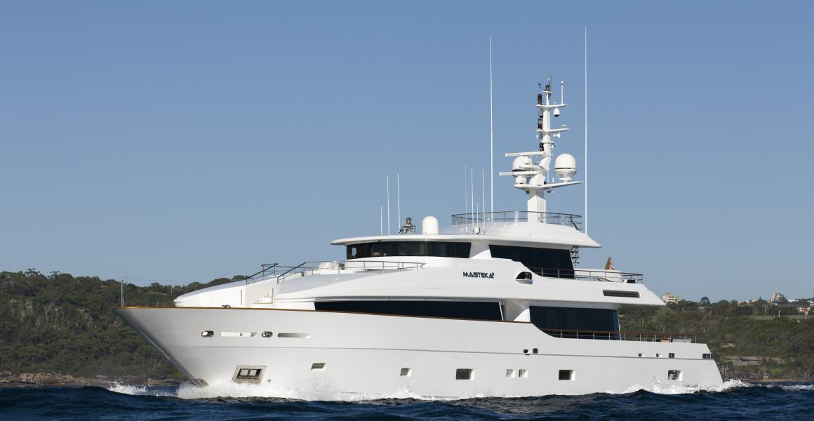 Masteka II **Enquire Now +61 2 98107200**

Picture 2 Picture 3 Picture 4 Picture 5 Picture 6

[http://stemccm.com/wp-content/uploads/2015/07/pagebreak.png](http://www.google.com.au/url?sa=i&rct=j&q=&esrc=s&source=images&cd=&cad=rja&uact=8&ved=0ahUKEwjgvN29xKvNAhUhH6YKHVSuC4MQjRwIBw&url=http://stemccm.com/teacher-professional-development/ccss-m-lesson-library/number-and-quantity/&bvm=bv.124272578,d.dGY&psig=AFQjCNHux1IExGnxcBf-ti4a4S6UuwramA&ust=1466131662117048)Quick Specs

**Rate:** From $3000 AUD / Hr , $100,000 US/ week **Length:** 37m **Built:** 2009 **Guests:** 80 cruising, 12 sleeping

 Masteka 2 is an elegant superyacht with expedition capabilities, perfectly suited to the South Pacific environment. Nominated for superyacht of the year in the 30-40m category 2009, her Dubois styling shines in every aspect of her design.  
  
Masteka 2's expansive deck space, sleek lines and great layout make her an elegant and functional choice when chartering the South Pacific. She is seaworthy enough to comfortably cruise long passages, compact enough to take guests right up close to all the hidden wonders of the pacific and spacious enough to give each guest their own slice of paradise.  
  
Her crew are one of the most experienced in the South Pacific they have a high sense of responsibility and safety awareness and participate in ongoing training programs aboard the yacht.  
The varied cultures and backgrounds of the crew have resulted in a dedicated team which provides an exciting and friendly atmosphere. Ultimately you are in the best hands aboard Masteka 2. The team are trained to anticipate and meet your every need.

Masteka 2 bases in Sydney for Christmas and New Years and will be in Fiji for charter from March through September. She can also be available for charters out of Cairns on the Great Barrier Reef and in the Whitsundays. Please enquire for details.

**Charter Locations:** Sydney, Pittwater, Whitsundays, Cairns, Fiji, New Caledonia